**Custom Map and Mobile Tracking System for UET Lahore**



**Session 2023 - 2027**

**Submitted by:**

Amir Hashmi 2023-CS-11

Sher Muhammad 2023-CS-15

Sheharyar Zahid 2023-CS-30

**Supervised by:**

Sir Nazeef-ul-Haq & Sir Waseem

**Course:**

CSC-200 Data Structures and Algorithms

Department of Computer Science

**University of Engineering and Technology  
Lahore Pakistan**

Contents

**1. Project Overview: 3**

1.1. Summary: 3

1.2. Motivation: 3

1.3. Objectives: 4

1.4. Target Audience: 4

1.5. Operational Details: 4

**2. Key Features and Data Structures Utilization: 5**

2.1. Map Representation With Graphs: 5

2.2. Shortest Path Calculation: 6

2.3. Category-Based Hierarchical Location Display with AVL Trees 6

2.4. Tracked Device’s Location History with Linked List: 6

2.5. Campus-Wide Maintenance Route Optimization with Minimum Spanning Tree: 7

2.6. User Authentication and Device Tracking: 7

2.7. Search History Tracking with Stack: 7

2.8. Bookmarked Locations with Queue: 7

2.9. Popular Locations Display with Sorting 8

**3. Wireframes: 8**

**4. Tech Stack Used: 16**

**5. Conclusion: 16**

**6. Future Improvements: 16**

**7. References: 17**

7.1. GitHub Project: 17

# **Project Overview:**

* 1. **Summary:**

This project introduces a custom map application for UET Lahore, designed to simplify campus navigation by providing efficient location searching and route optimization functionalities. The system is built with algorithms such as the Minimum Spanning Tree (MST) and Dijkstra's Algorithm to generate the most efficient paths between various campus locations. It allows users to search for specific locations, such as academic blocks, departments, hostels, or cafeterias, and provides optimized routes to their destinations.

The application eliminates the need for traditional physical maps or generic navigation apps, offering a tailored solution that addresses the unique layout and requirements of UET Lahore's campus. With features like real-time location-based queries and route planning, this project enhances the accessibility and efficiency of campus navigation for students, faculty, and visitors alike.

* 1. **Motivation:**

Navigating large campuses like UET Lahore has always been challenging, especially for new students and visitors unfamiliar with the layout. Finding the shortest routes between locations or understanding the spatial layout of a complex campus is time-consuming without a specialized tool.

This project aims to solve these challenges by providing a custom-built application tailored to UET Lahore. By incorporating search functionalities and efficient route optimization, the application reduces time spent navigating the campus, minimizes confusion, and enhances the overall user experience.

* 1. **Objectives:**
* Develop a user-friendly, custom map interface with interactive tracking and navigation features.
* Implement efficient data structures and algorithms to handle location-based queries, history tracking, and search functionalities.
* Enable real-time location tracking and logging of movements within the campus.
* Maintain a secure, personalized experience by saving user and device data for tracking and preferences.
  1. **Target Audience:**
* **Students:**

To search for academic buildings, departments, and other campus facilities with ease.

* **Faculty and Staff:**

To navigate the campus efficiently and reduce the time required to reach specific destinations.

* **Round Visitors:**

Inspection teams, administrative visitors, or external delegations who need to visit multiple locations within the university.

* 1. **Operational Details:**

The custom map system for UET Lahore provides a streamlined navigation and campus management solution with the following functionalities:

* **Interactive Campus Map**:

Displays locations like departments, libraries, and cafeterias with paths and distances for easy navigation.

* **Shortest Route Finder**:

Calculates the most efficient path between any two locations.

* **Category-Based Location Display**:

Organizes nested locations (e.g., shops within SSC) in a hierarchical format for better visualization.

* **Location History Tracking**:

Maintains and displays past movements for tracked devices.

* **Optimized Multi-Location Routes**:

Generates efficient routes for campus inspections or maintenance tasks.

* **Search and Bookmark Management**:

Allows users to track recent searches and bookmark favorite locations for quick access.

* **Popular Locations Display**:

Highlights frequently visited locations based on user activity.

* **User Authentication**:

Ensures secure, personalized access to system features.

These functionalities make the system efficient, user-friendly, and adaptable to campus needs.

# **Key Features and Data Structures Utilization:**

# **Map Representation With Graphs:**

* **Data Structure**: Graph (Adjacency List)
* **Description**: The map of UET Lahore is represented as a graph, where each location (e.g., departments, libraries, cafeterias) is a node, and paths between them are edges with weights (representing distances).

# **Shortest Path Calculation:**

* **Data Structure**: Dijkstra’s Algorithm
* **Description**: To find the shortest path between any two nodes on the map, Dijkstra’s algorithm is implemented. This feature allows users to navigate efficiently between locations on campus.

# **Category-Based Hierarchical Location Display with AVL Trees**

* **Data Structure**: AVL Trees
* **Description**: Specific locations, such as SSC, are organized as AVL Trees, with each node representing a sub-location (e.g., various shops in SSC). This hierarchical structure allows for organized data access and visualization of nested locations.

# **Tracked Device’s Location History with Linked List:**

* **Data Structure**: Doubly Linked List
* **Description**: A doubly linked list is used to track the real-time location history of a device. Each node store the device’s location coordinates along with a timestamp, enabling tracking of its movements. This structure allows efficient retrieval of the device’s travel path, helping locate it by reviewing past locations. The list is also used to identify the last known position of the device.

# **Campus-Wide Maintenance Route Optimization with Minimum Spanning Tree:**

* **Data Structure/Algorithm**: Minimum Spanning Tree (MST) - Prim’s or Kruskal’s Algorithm
* **Description**: For users such as the maintenance team, an MST algorithm is used to generate a path that covers all connected locations with minimal travel. This feature optimize the maintenance team’s route, ensuring they visit all necessary locations efficiently.

# **User Authentication and Device Tracking:**

* **Data Structure**: Hash Map (for storing user data and device IDs)
* **Description**: Users are required to sign up and log in, with their device IDs saved in a hash map for device-specific tracking. This enables personalized tracking and a secure, user-specific experience.

# **Search History Tracking with Stack:**

* **Data Structure**: Stack
* **Description**: A stack stores the history of location searches, allowing users to view their recent searches in Last-In-First-Out (LIFO) order. Users can revisit previous locations with ease, improving the user experience.

# **Bookmarked Locations with Queue:**

* **Data Structure**: Queue
* **Description**: Users can bookmark their favorite or frequently visited locations, stored in a queue to manage these locations in a First-In-First-Out (FIFO) order.

# **Popular Locations Display with Sorting**

* **Data Structure/Algorithm**: Sorting Algorithm (Merge Sort)
* **Description**: Search history can be processed to identify frequently visited locations. Applying sorting algorithms will help rank these locations, ad display the most popular spots on campus.

# **Wireframes:**

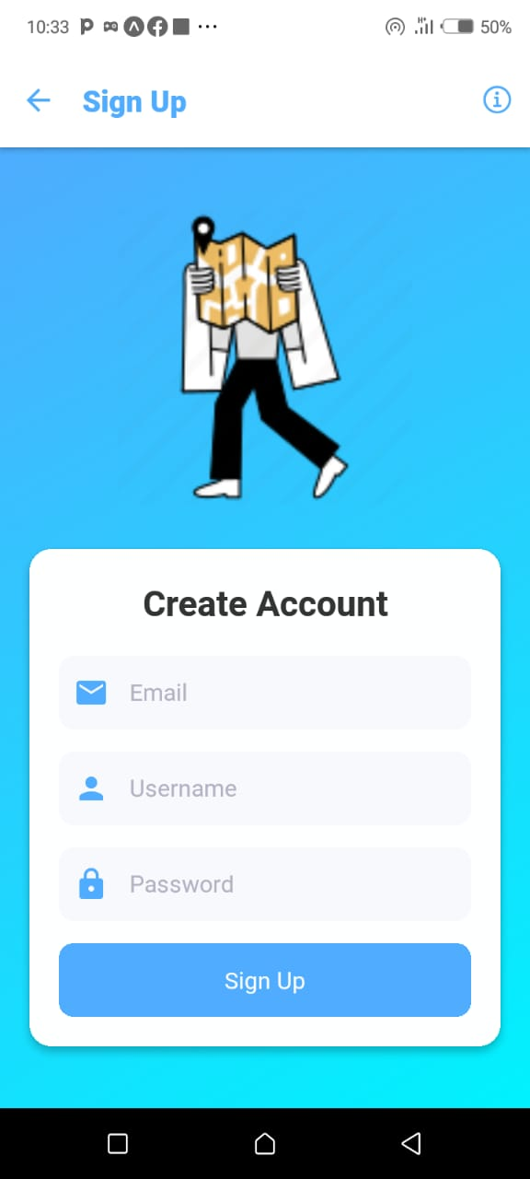

**Mobile App Signup**

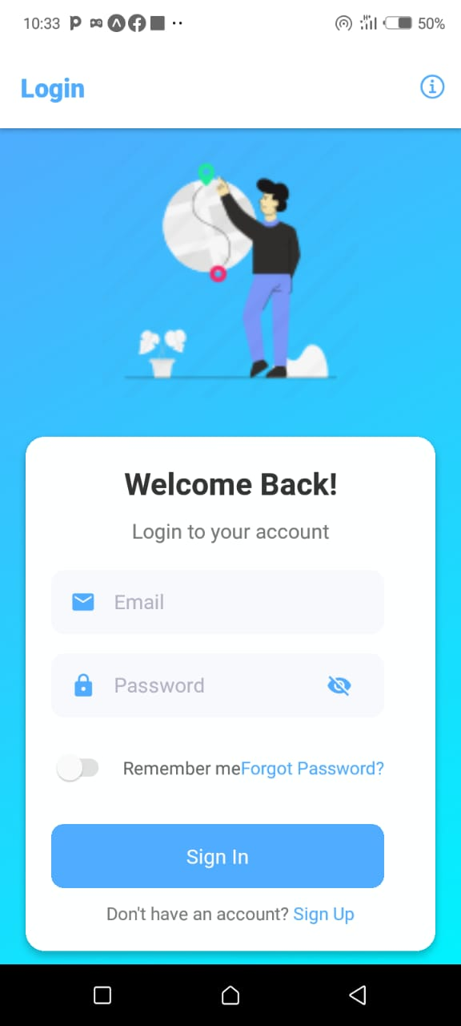

**Mobile App Login**

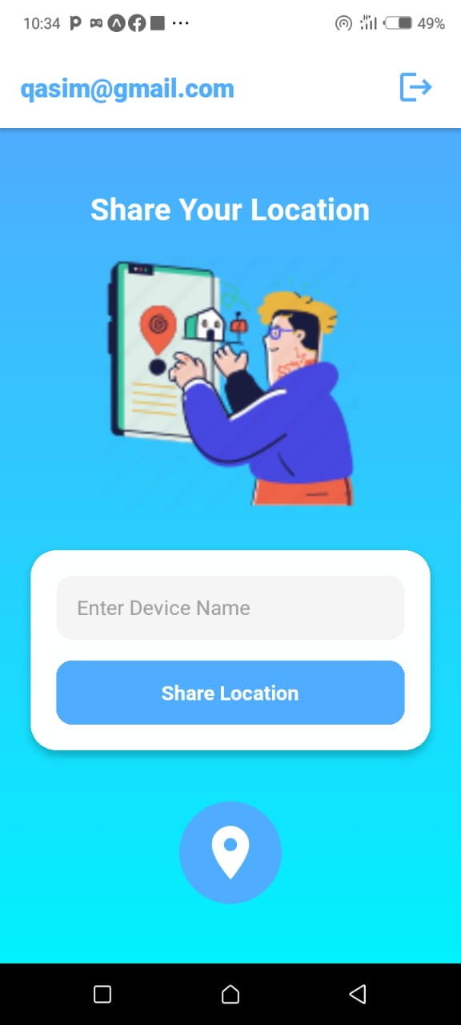

**Mobile App Location   
Sharing Page**

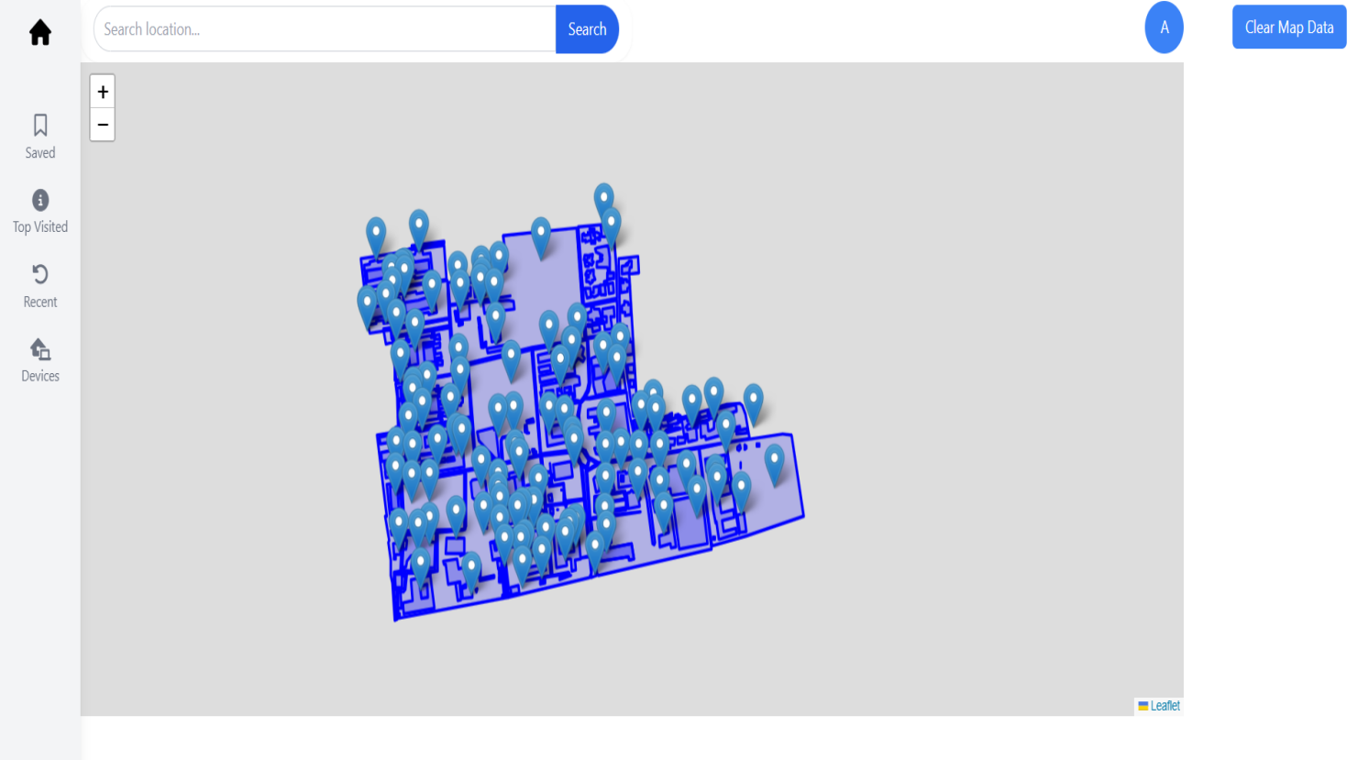

**Map Navigation View**

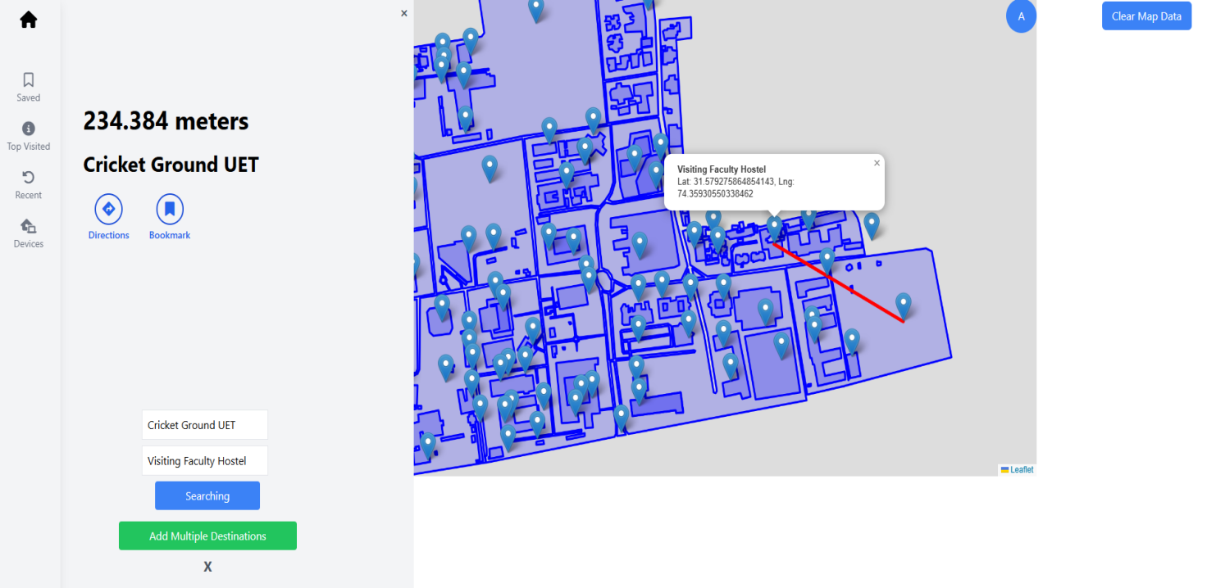

**Shortest Path Search**

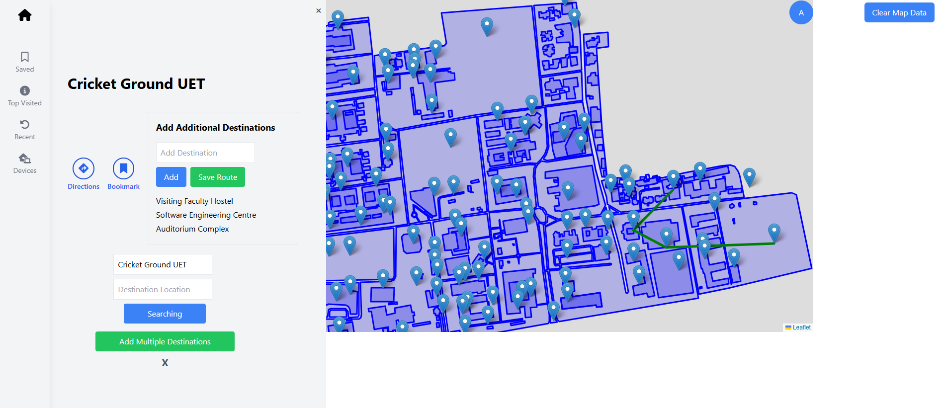

**MST Route Searching**

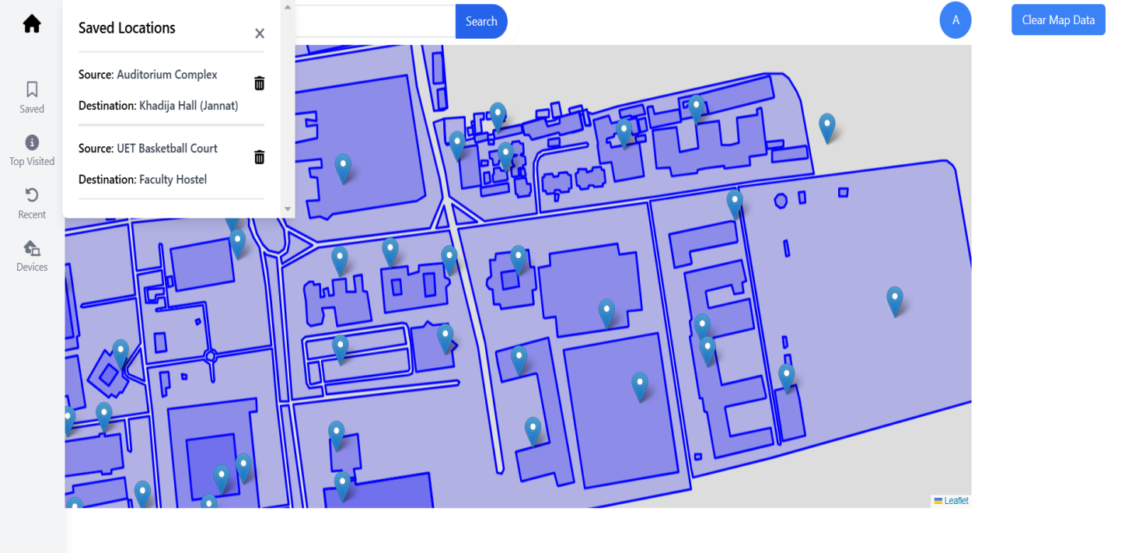

**Saved Locations**

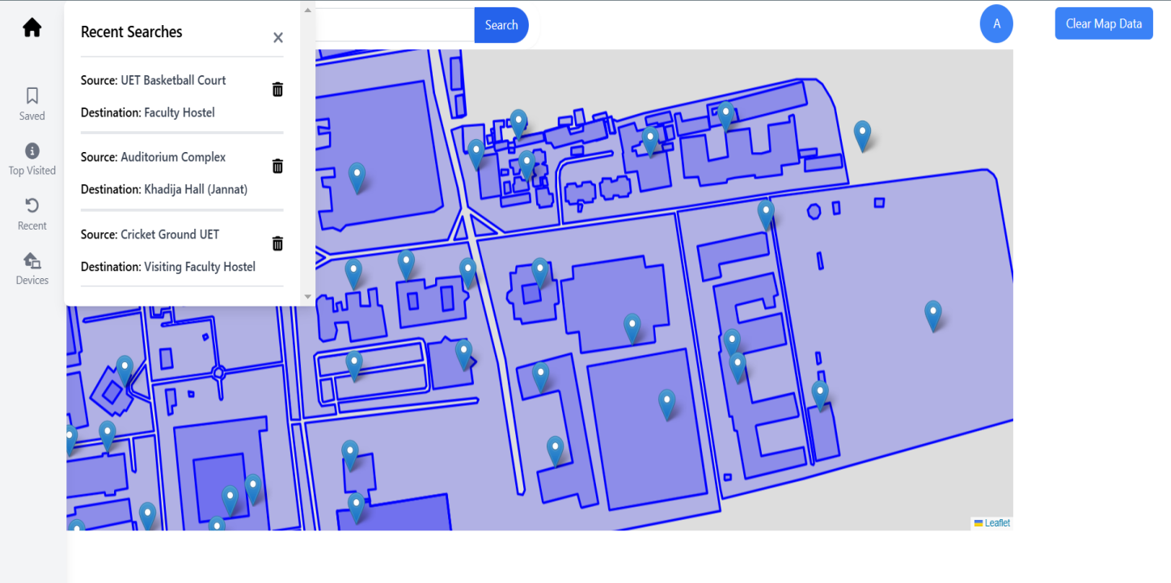

**Recent Searches**

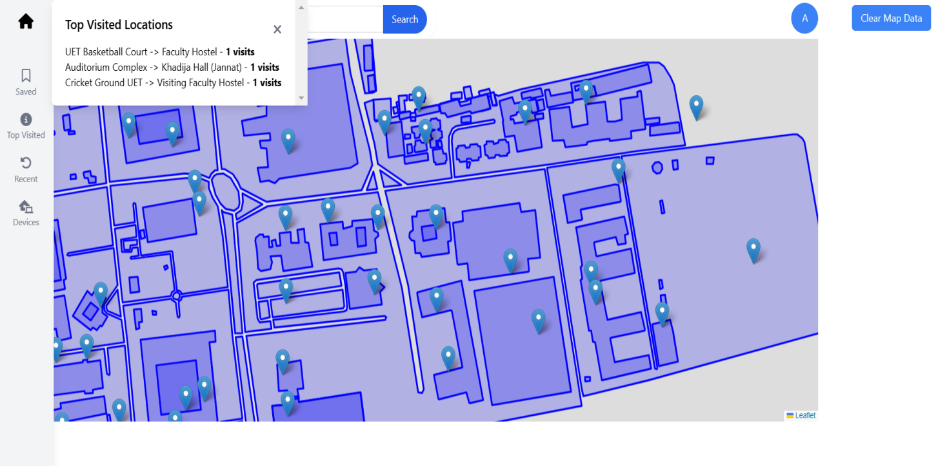

**Top Visited Locations**

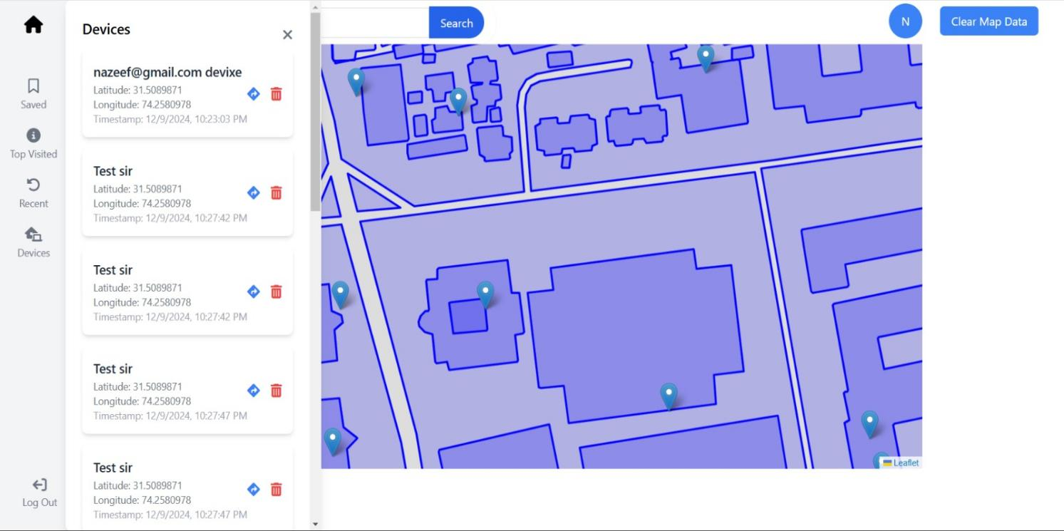

**Device Location Tracking**

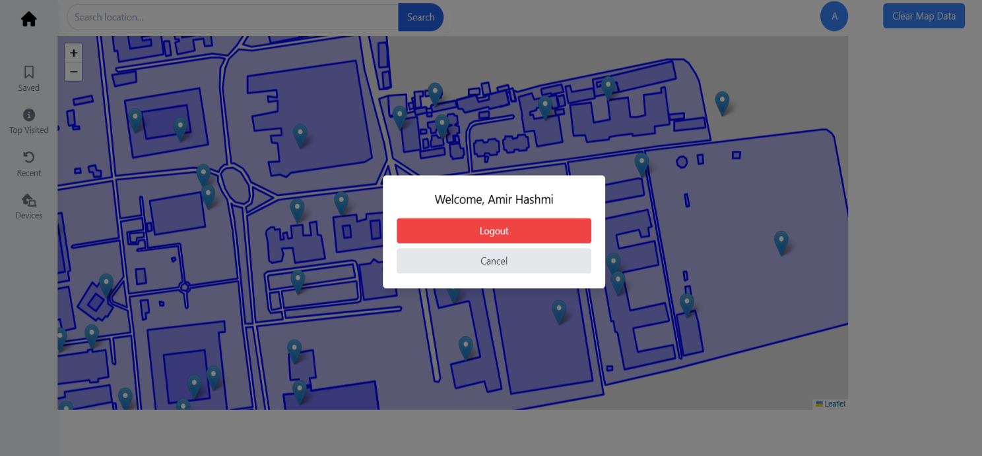

**Logout Modal**

# **Tech Stack Used:**

* **Web App:**

The web application is developed using **React.js, Node.js, Express.js**. The backend will handle algorithms and real-time tracking, while the frontend will provide interactive map visualization. **Postman API** is used for testing of backend APIs.

* **Mobile App:**

The mobile application developed for sharing locations is built using **React Native** and tested with **Expo**.

# **Conclusion:**

This project is an innovative application of data structures and algorithms in a real-world setting, providing a valuable service for students, staff, and maintenance teams at UET Lahore. It integrates concepts from data structures, algorithms, and software engineering into a comprehensive, user-friendly navigation system tailored to campus needs.

# **Future Improvements:**

* **Dynamic Map Updating:**

Introduce real-time updates to reflect changes in campus layout, such as new buildings, pathways, or facilities.

* **Real-Time Traffic Monitoring:**

Implement real-time data for foot traffic and congestion on campus pathways to suggest alternate routes during peak hours.

* **Voice-Based Navigation:**

Include a voice-guided navigation feature for enhanced accessibility and convenience.

* **Mobile Application Development:**

Develop a dedicated mobile app for Android and iOS platforms to provide a seamless on- the-go experience.

# **References:**

* 1. **GitHub Project:**

# [**https://github.com/AmirHashmi017/DSA-Final-Project**](https://github.com/AmirHashmi017/DSA-Final-Project)